https://www.postman.com/downloads/

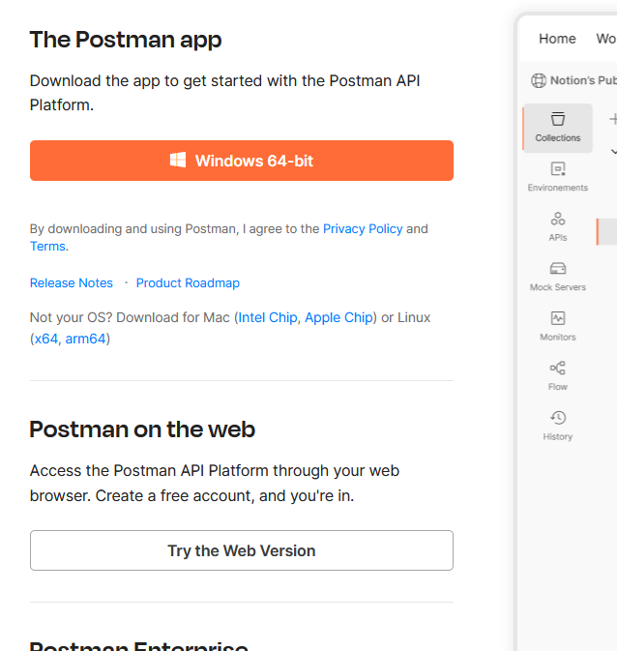

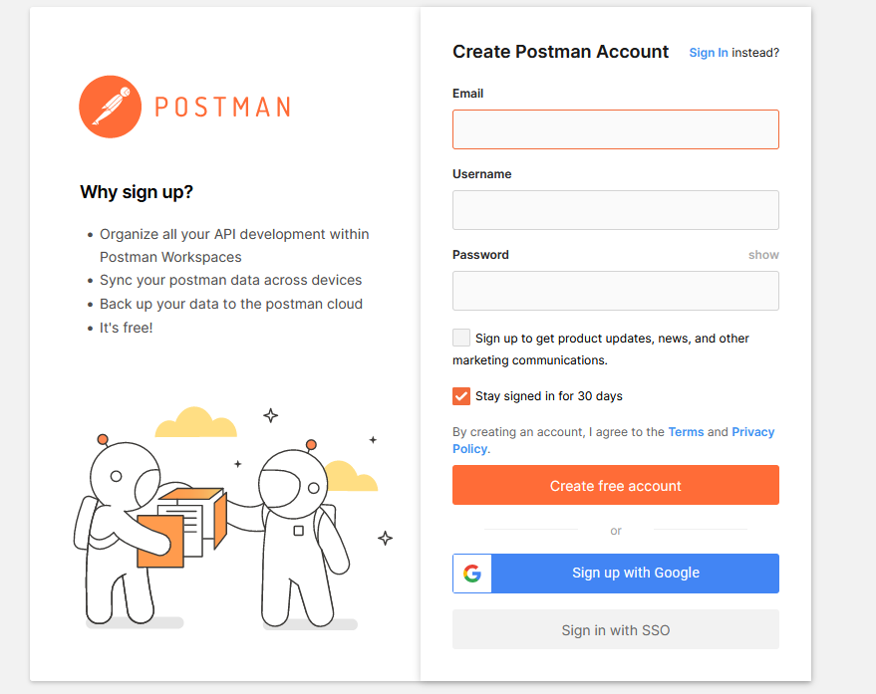

https://www.postman.com/cs-demo/workspace/public-rest-apis/collection/8854915-454a2dc7-dcbe-41cf-9bfa-da544fcd93a2

fork the collection

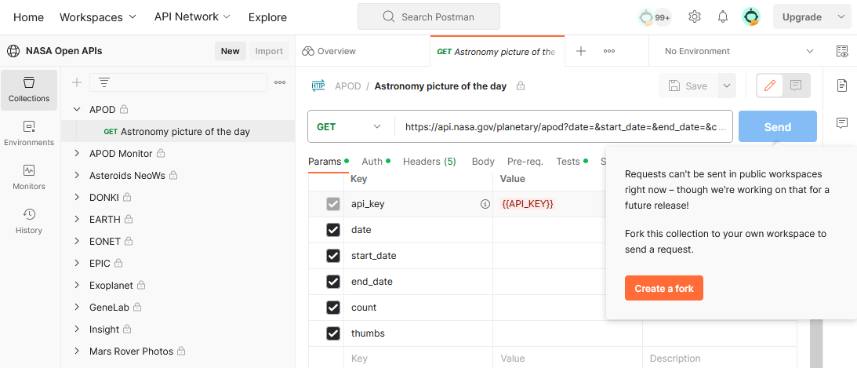
https://www.postman.com/miguelolave/workspace/nasa-open-apis/request/3419756-78100262-1086-43d3-88e2-f40332bb0e92

